Jakub Olszewski
23710521
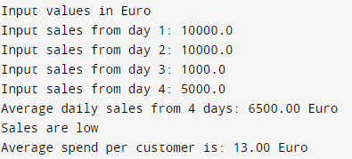

Code:
#include <stdio.h>
// Function calculates the sum of the array
float arraySum(const float sales[4]) {
float sum = 0.0f; // Initialize sum
for (int i = 0; i < 4; ++i) { // Iterate through all elements
sum += sales[i]; // Add each element to sum
}
return sum; // Return sum
}
// Function calculates the average of the array
float averageSales(float sales[4]) {
return arraySum(sales) / 4.0f; // Using arrySum function to calculate the average sales
}
// Function calculates the average spend per customer
float avgSpendPerCustomerDaily(float sales[4]) {
float customers = 500.0f; // Number of customers
float avgSpend = arraySum(sales) / (customers * 4.0f); // Using arraySum function to calculate the average spend per customer
return avgSpend; // Return average spend per customer
}
// Function returns a message based on the average sales
// Using a function to return a message based on the avarage is more efficient
// than using if statements in the main function, because of the inversion of statements
char *salesValueMsg(float avgSales) {
if (avgSales > 15000.0f) // If average sales are higher than 15000 return "Sales are very high"
return "Sales are high";
if (avgSales >= 10000.0f) // If average sales are higher than 10000 return "Sales are high"
return "Sales are normal";
return "Sales are low"; // If average sales are lower than 10000 return "Sales are low"
}
int main() {
printf("Input values in Euro");
float dailySales[4]; // Array to store the daily sales
for (int i = 0; i < 4; ++i) {
printf("\nInput sales from day %d: ", i+1);
scanf_s("%f", &dailySales[i]); // Input sales from each day and saving them in array dailySales
}
float avgSales = averageSales(dailySales); // Calculate the average sales
printf("Average daily sales from 4 days: %.2f Euro", avgSales);
printf("\n%s", salesValueMsg(avgSales));
printf("\nAverage spend per customer daily is: %.2f Euro", avgSpendPerCustomerDaily(dailySales));
return 0;
}

